Rules for Chess MIni-Games
General Rules and Protocols
- All games start with a friendly handshake and, if the players don’t know each other, by introducing themselves.
- Colours can be decided by the teacher or by the “Handies” method: the older player hides a pawn of each colour in his / her hands and the younger player picks a hand.
- If you touch a piece, you must move it and if you touch an opponent’s piece, you must capture it if you can. If you brush against a piece by accident, say “that was an accident” immediately, to avoid arguments. If you want to adjust a piece on its square, say something like “I’m adjusting” or “I’m fixing this”.
- Once you have taken your finger off a piece after moving it, you have to leave it on that square.
- In any argument regarding rules 3 or 4, it’s good manners to give your opponent the “benefit of the doubt”.
- You are not allowed to give, receive or ask for any advice during a game. The game is yours and yours alone.
- When the game is over, players should shake hands again. The winner should say “hard luck” and tell the loser it was a good game and s/he played well; the loser should say “well played” or “well done” to the winner.
Note to Teachers: the rules for each game follow. They are explained using standard chess diagrams, and White is always moving “up the board” and Black “down the board”. You will see grid references (letters and numbers) on each board and this gives every square a name (for example b3 is the 3rd square up on the line marked “b”.)
I have used the square names for some explanations, but you need not introduce them to the children unless you wish – I always find they have no problem understanding them!
The videos on www.movesforlife.ie are a great introduction to the games.

Game 1: Pawn Wars:
This game just uses pawns. Each player has 8 pawns (the smallest pieces in your chess set) and you set them up on the second row of the chess-board nearest to you, like this:

Black
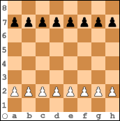
White
White moves first (as in all chess games), and then each player takes it in turn to move.
Pawns move forwards, one square at a time. On any pawn’s first move, you may advance it two squares instead of just one. Pawns cannot move backwards.
Pawns capture diagonally.
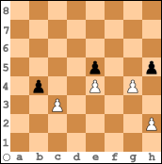

In this position, it’s White’s turn. The choices are:
- The pawn on h2 can move either one square forward or two squares forward.
- The pawn on c3 can capture the Black pawn on b4.
- The pawn on g4 can take the Black pawn on h5.
- You don’t have to capture, even if you can. So White’s pawns on c3 and g4 could both just move one square forward.
- The pawn on e4 can’t move. It’s blocked.
In the game of Pawn Wars, you win by getting one of your pawns to the far end of the board first. Just one pawn will do!
If the position gets blocked up and no-one can move, the winner is whoever has the most pawns.
Game 2: Cat ‘N Mouse (Rook):
In this game, Black has a rook and White has four pawns. You can set them up like this:
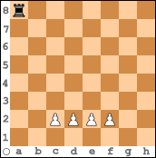
Rooks can be moved forwards, backwards or sideways, as many squares as you like so long as they are not blocked. They can capture any enemy piece that is in their way.
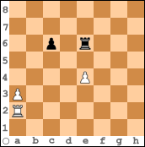
For example, in this position the White rook can move sideways to b2, c2, d2, e2, f2, g2 or h2, or backwards to a1. It can’t be moved forwards because the White pawn on a3 is blocking it. The Black rook can move sideways to d6, f6, g6 or h6, backwards to e7 or e8, and forwards to e5. It can also capture the White pawn on e4.
In the game of Cat ‘N Mouse, White moves first. White’s aim is to get a pawn to the end of the board, while Black tries to use the rook to capture all the White pawns. White wins either by getting a pawn to the end of the board. If a pawn reaches the end of the board but can immediately be captured, the pawns do not win – it must reach the final square safely. White can also win by capturing the Black rook. Black wins by capturing all the White pawns.

Game 3: Cat ‘N Mouse (Bishops):
In this game, White has two bishops and Black has six pawns. At the start, set up like this:
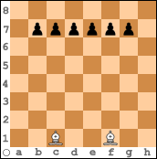

Bishops move diagonally, as many squares as you like so long as they’re not blocked. One bishop operates on the dark squares and one on the light squares. Bishops capture in the same way as they move.

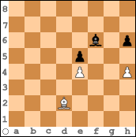

In this position, for example, the White bishop can move to c1, c3, b4, a5, e3, f4, or g5 and can capture the Black pawn on h6. The Black bishop can move to e7, d8, g7, h8, or g5, and can capture the White pawn on h4.
In the game of Cat ‘N Mouse (Bishops), White moves first. White wins by capturing all the pawns while Black wins by getting one pawn to the far end of the board.
Again, the pawn must reach the end safely in order for Black to win.

Game 4: Killer Queen:
In this game, White has 8 pawns and Black has a queen. Set up like this:

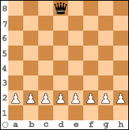

A queen moves like a combination of rook and bishop, so she is very powerful. She can move forwards, backwards, sideways and diagonally, as many squares as you like so long as she is not blocked, and she can take any enemy piece in her path.
When you are introducing this game, it’s an idea to advise the White players to start by playing the pawn on d2 one square forward. This will protect it from being captured, as the queen would be putting herself at risk if she takes the pawn.

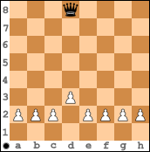

If Black captures the White pawn on d3 now, White can capture the queen with either the pawn on c2 or e2.
In “Killer Queen”, Black wins if the queen captures all the pawns. White wins by getting one pawn safely to the far end of the board.

Game 5: Cat ‘N Mouse (Knights):
Start by pitting two knights against three pawns. This favours the knights a lot, but it’s a good idea for beginners as the knight has a particularly tricky move: forwards or backwards one square, then sideways two – or sideways two squares, then forwards or backwards one. In this position, for example, the knight can capture any of the pawns.

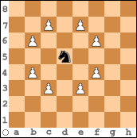
And don’t forget that the knight is the only chess piece allowed can hop over other pieces!
This is a possible start position for Cat ‘N Mouse (Knights):
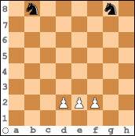

If someone can win comfortably with the knights, it’s time to add more pawns! Again, White moves first, and White wins if a White pawn reaches the end of the board safely; Black wins if the knights capture all the pawns. Black does not automatically lose if s/he loses a knight, as there is still one knight left to stop the pawns.
In this game, if the knights manage to block the pawns so the pawns have no legal move, the game is a draw. For example:

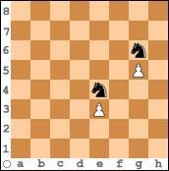
Game 6: Super Cats:
In this game, eight pawns battle against a rook, a bishop and a knight. The set-up can be something like this:

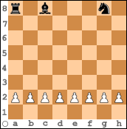

As with the Killer Queen game, you may want to give the White players a little advice at the start. They should move the pawn opposite the enemy rook (the pawn is on a2 in the above diagram) one square forward so that it is protected (guarded) by the pawn on b2. If the White player doesn’t take your advice and allows the rook to take the pawn on a2, that rook is going to gobble a lot of White pawns by moving sideways – when I’m explaining this to children I say “You’ve allowed the fox get into the hen-coop!”
Again, Black wins if s/he manages to take all the White pawns; White wins if s/he manages to get a pawn safely to the far end of the board.
Watch out for players with the Black pieces only moving the rook. This is the easiest piece to use but it won’t be enough to stop eight pawns!

Game 7: King and Pawn Wars
This game is exactly the same as Game 1 except that kings have been added. The pawns go on the second row again, and the kings on the back row, on a central square of the opposite colour – Black king on a white square, White king on a black square:
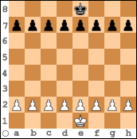
Again, the aim of the game is to get a pawn safely to the far end of the board. In real chess this is called “promoting” a pawn, because you are allowed to change the pawn into a more valuable piece – people usually choose the queen, of course. In this game, the player who manages to “promote” a pawn first is the winner.
The important aspect of this game is to use your king. Kings move one square only in every direction, and can be surprisingly powerful.
You may or may not want to introduce the rule here that kings may not be captured.
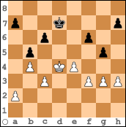
So for example, if the White king in this position were to move to e5, the Black player cannot take the king with the pawn on f6. Instead the Black player should say “That move isn’t allowed, you have to make a different move.” As the White player has touched the king, the move has to be with the king.

Game 8: Rook Rout (Total Wipe-Out)
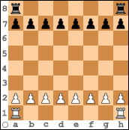
Set the pieces up as above. If a pawn gets to the end of the board it is “promoted” to a queen, and you can have as many queens as you like!
The game continues until either one army has all been captured or until “time up” is declared by the teacher. At “Time Up” the piece values are counted: a pawn is worth 1, a rook is worth 5 and a queen is worth 9. Whoever has the highest value in pieces on the board is the winner.
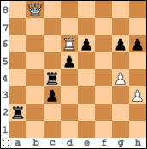
For example, in this position White has a queen (9 points), a rook (5 points), and two pawns (2 points). Total 16.
Black has two rooks (10 points) and 5 pawns (5 points). Total; 15.
So White wins.

Game 9: Total Wipeout
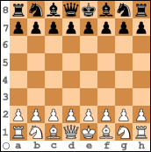
Set up for the start of a real game of chess. For fun, you can let the players have a race to see who sets up correctly first!
The aim of this game is to take as many enemy pieces as you can without losing too many of your own. There is no “check” or “checkmate”, just moving and capturing. However, the king cannot be captured, just like in a real game.
When the teacher calls “Time Up”, the values of the pieces on the board are counted up and the winner is the player with the higher count.
The Table of Values is as follows:
Queen: 9 points
Rook: 5 points
Bishop: 3 points
Knight: 3 points
Pawn: 1 point.

Game 10: Bishop Battle:
Set this position up at the start:
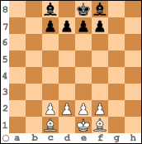
The players take it in turns to move and capture, as usual. (White moves first.) The aim of the game is to check the enemy king twice. “Check” in chess means to attack the king.
For example in this position White’s king is “in check” from the Black bishop on b4:
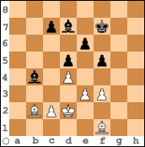
When a player’s king is “in check” (under attack from an enemy piece), s/he must “get out of check” by either (1) capturing the checking piece if possible, (2) moving the king to a safe square or (3) blocking the check with another piece. In the above position, White cannot capture the checking bishop, but s/he can move the king to a safe square (e.g. d1) or block the check by putting either a pawn or a bishop on c3.
In the above position, if White moved the king to safety by putting it on d3, Black could win the game immediately by playing the other bishop up to b5, checking again. Two checks win the game! (They don’t have to be consecutive, as in this example.)
If no-one has got two checks by the time “time up” is called, the game is a win for the player with the most points on the board.
Watch out for players “stalling” (moving very slowly or not at all when they are ahead so as to win when “time up” is called), as this is a great opportunity to have a discussion about sportsmanship!

Game 11: Three-Check Chess
The game is set up as for a real game of chess:
The winner is the player who manages to check the enemy king three times.
Game 12: Checkmate the King!
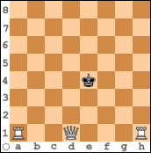
This is the start-up position for this game. Each player takes it in turn to be White. The object of the game is to checkmate the Black king. At first this is enough of a challenge, but then you may want to make it a bit more competitive by seeing which player can use the fewest moves to get the checkmate.
Note that if you leave the king with no legal moves, but he’s not in check, this is called “stalemate” and it’s a draw! Example:
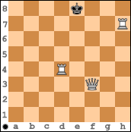
It’s Black’s turn and the king is not in check, but has nowhere safe to go. Draw!

Game 13: Rook Roller
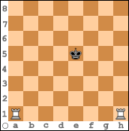
This is very similar to Game 12, as the object is to checkmate the Black king. Again, the players should take it in turns to be White.

Game 14: Full Chess
Your students should now be ready for a full game of chess. They know how all the pieces move, and also about check and checkmate. It’s unlikely that they will get many checkmates at first – most games will be decided by piece-counting at “time up” time. Good mental maths practice!
When they have been playing for a few weeks, you can introduce the last major rule, “castling”. There are a few other rules which you needn’t bother with for a while, e.g. “perpetual check” and en passant captures. Leave them for much later!

Good Luck with your Chess Club!

