Ideas for Teaching with Chess :

National Chess Month (NCM) is from the 5th to 28th of November 2018. The aim of NCM is to support chess for within the schools curriculum. Here are some things that students can learn .

Introduction to areas of the School Curriculum that can be learned through chess:

NCM is for Teachers & Students new to chess .. it covers many elements of the school curriculum :

- Social Skills:
Rewarding good behaviour, including fair play, use of appropriate language, helping each other and equipping students with ways to cope with defeat. How to integrate the curriculum with games is in the suggested LESSON PLANS below.
- Maths:
Numeracy is required to decide the winner of some beginner games. It is also used by students identify good moves and best moves in the “Rook Rout” and “Total Wipeout” games.
- Thinking skills:
Making good decisions by thinking before you move relates to Ethics / SPHE.
- Predicting skills:
For check only games, identify an opponent’s plan (risk) and stop it before danger arises.
- Planning skills:
Find a plan and co-ordinate pieces e.g. checkmate games.

Here’s a list of easy to play “starter” games for teachers and players new to chess:

Here are some beginner games your students can play right away.

There is a 2 minute demo videos on YouTube channel “chessOssity” for every starter game.

The first Skills game we play is ..
(1) “Pawn Wars”. Once students learn this game they can move onto the Cat n’ Mouse games.
Simply watch the video .. and play!

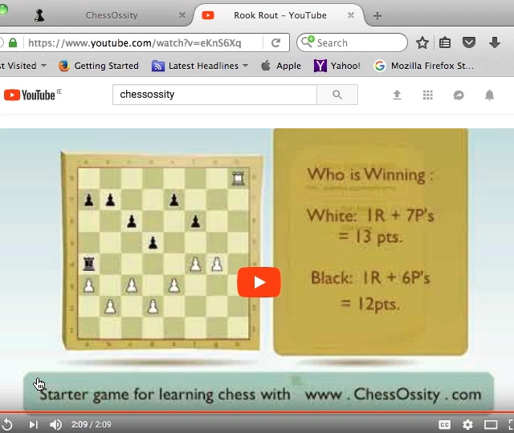
The Cat n’ Mouse games introduce each chess piece one at a time. They are ..
(2) Rook Rampage - C n’M ,
(3) Bishop Blitz - C n’M ,
(4) Killer Queen - C n’M ,
(5) Knightmare - C n’M
Introduce the King,..
(6) Pawn Wars with Kings.

The Pawn Wars and C n’M games are the perfect time to create an environment that will reward good behaviour .. see “Social Skills” below for details.

It is best to introduce a new game only when you feel your group are ready to move ahead. No hurry.

Chess works best when it fun for players. Kids can be rewarded for fair play, being nice to each other etc. by progressing to new games.

Following Cat n’ Mouse games are the Wipeout games ..

In the Wipeout games students use all the skills learned from the Cat n’ Mouse and use maths to decide what is a good move and a bad move. These videos are called:
(7) Rook Rout.
(8) Total Wipeout.

The next type of learner games are the “Checking” games. They introduce a new aspect of chess .. defending our King.
Thinking Skills used, Players identify threats by predicting opponents moves and take precautions.
These videos are called:
(9) Bishop Battles.
(10) Three check chess.

The final skills game are Checkmate games. For students who have completed all the skills games this is a short last step to playing a full game of chess.
Thinking skills: Planning and co-ordinating movement of only a few pieces.
These videos are called:
(11) Queen + 2 Rook checkmate and
(12) 2 Rook checkmate.
Now students are ready to play a full game of chess ! But there is no hurry to reach this point .. half the fun is in learning the skills games.
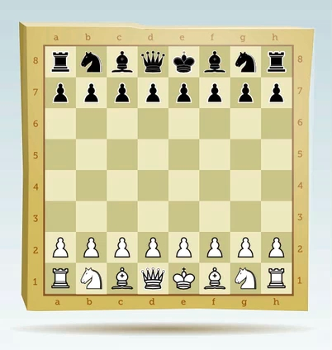

Above is the starting position for a full chess game.

Schools new to chess taking part in NCM ?

Easy, play a mini-game in class and post details of your experience facebook via link on www.movesforlife.ie .

You coul follow on by challenging another school to a starters game of chess.
Every post goes into a draw for a 1st prize of €500.00 to the winning class.

NCM chess Jamborees ..

Email us ncm2018@movesforlife.ie to register your school for a chess Jamboree.
The first 10 schools to contact us will get a €200.00 grant towards your event which can be used for prizes or to purchase chess equipment.

Activity Plan:
( Game 1 - Pawn Wars )

Why we do it: This is the easiest game to play, as it uses only 1 piece. It’s the foundation for the mini-games that follow. An easy game gives us time to create a good environment working on behaviour and social skills

Aim is to promote mutual respect and emphasize the importance of learning over winning.

Action: | Learning:
Shake hands at the start of a game and wish your opponent “good luck”. | To show respect and friendliness.

- First Game – Pawn Wars (approx. 30 mins).
- Students put away all books and clear their desks, in order to make room for chess sets. Players can arrange their desks & seats so that they are facing an opponent.
- Play 2 minute YouTube video of Pawn Wars.
- Tell student why they are playing .. (i) To learn. (ii) To enjoy play time. (iii) They can do friendly talk (quietly), but only friendly talk when playing. (iv) There should be no arguing. “ What do you do if there is a problem ? “ Hands up and ask for teacher’s help.
- Players confirm they understand the rules of conduct.
- Pass out chess sets, and have all the class set up the board exactly as it is on the YouTube video.
- Everyone can start at the same time; this allows a pause when you can instruct players to shake hands (nicely) and wish each other “good luck.”
- As games finish players can get a turn with both White and Black pieces.
- Move players around to new opponents, best to pair the guys who won against other players who won their first games.
- Call time up after approx 15 mins. Students should put away sets and ensure everything is neat and tidy.
- Finally .. Give group feedback on behavior. You can note anything important during the games.

Sample Feedback: | Next time:
(1) Well done .. there was a lot of friendly talk.  (2) One thing .. is calling another player a “cheat” friendly ? (no)  If someone makes a mistake .. that is OK .. that is part of learning ! | That’s our standard for next time. You can do that every time we play games.  So next time… I want to hear players say: “I think that’s a mistake” and ask for teachers help to fix.  Nobody should be arguing. (ok ?)
Games are a success when children enjoy playing them and want to play again and again. The reward for teachers is good behaviour.

Activity Plan:
( Game 2 - Cat n’ Mouse , Rampaging Rook )

Why we do it: Keeping it easy for students we introduce a new piece. And continued focus on creating a nice environment.

Action: | Learning:
(1) Shake hands & “good luck”.  (2) Introduce the “touch a piece move a piece rule”. There can be no taking back moves. | Feedback from lesson 1 .. if any ..  Thinking Skills – look carefully before touching any piece.  Fair play – reward players who follow the rule (praise).

- Second Game (approx. 30 mins).
- Students arrange their desks and seats ready to play.
- Play 2 minute YouTube video of game 2 OR use game 1 again if you feel that a reminder game is called for. No hurry.
- Reminder .. (i) Play to Learn & enjoy playing. (iii) Friendly talk (quietly), only. (iv) No arguing: if there is a problem, hands up and ask for teachers help.
- Players confirm they understand how to behave.
- Set up the boards exactly as it is on the YouTube video.
- Start all games at the same time, but first shake hands and say “good luck.”
- As games finish players can get a turn with both White and Black pieces.
- Move players around to new opponents.
- Call time up after approx 15 mins. Students should put away sets and ensure everything is neat and tidy.
- If necessary, give group feedback ..

E.G. Feedback: | Next time:
(1) Well done .. friendly talk & you asked me to look at mistakes !  (2) Touch move.... some players touching pieces before moving.  (3) Players are allowed time to think .. we cannot rush or try hurry them up. | Good standard for next time.  Remember to think first .. then move. Fold your arms or sit on your hands if you need to.  Be patient: while your opponent is thinking, you should use that time to see what they might do.

Activity Plan:
( Game 3 - Cat n’ Mouse , Bishop Blitz )

Why? Keeping it easy for students we introduce another new piece. And continue to focus on creating a nice environment.

Action: | Learning:
(1) Shake hands and say “good luck”.  (2) Revise “Touch Move” rule. Once a player moves a piece he cannot take the move back. | Revise feedback from lesson 2 .. if any ..  (be patient , don’t hurry opponent)  Take time to think.  Fair play: if you move it .. don’t try to change the move.

- Third Game (approx. 30 mins).
- Arrange desks & seats. .. Play next YouTube video .. OR revise other games. No hurry.
- Play for fun. Friendly talk. No arguing …ever.
- Set up boards as on YouTube. & All start together .. shake hands and say “good luck.”
- Players alternate between White and Black pieces. .. then Move players to new opponents.
- Call time up after approx 15 mins. .. Students take good care of sets so that everything is neat and tidy.
- If you feel it appropriate, give group feedback ..

E.G. Feedback: | Next time:
(1) Well done: friendly talk and you asked me to look at mistakes !  (2) Touch moves: some players touching pieces before moving.  (3) Give opponents time to think.  (4) NO boasting!! Games are for fun and learning. Nip gloating in the bud and if a kid’s feelings are hurt, make sure there is an APOLOGY. | Good standard for next time.  Remember: think first …then move. (sit on your hands if you need to!).  Be Patient .. good / or improved ..  NEVER OK: to gloat or trash talk. These are friendly games, for fun.

Activity Plan:
( Game 4 - Cat n’ Mouse , Killer Queen )

Why? Keeping it easy for students we introduce a forth piece. And continue to focus on creating a nice environment.

Action: | Learning:
(1) Shake hands and say “good luck”.  (2) Revise “Touch Move” rule.  (3) Remember .. appropriate talk only .. if a problem call teacher / don’t argue / ask for teachers help. | Respect.  Patience.  Build Friendly behaviour.

- Forth Game (approx. 30 mins).

- Arrange room .. Play video .. OR revise games (No hurry).
- Play for fun. Friendly talk. No arguing …ever.
- Set up boards & to start .. shake hands and say “good luck.”
- Players get a game with White & Black. Move players to new opponents.
- When ready Call time & Students take good care of sets.
- If appropriate, give group feedback ..

E.G. Feedback: | Next time:
(1) Friendly talk ..  If any poor language used , give  Alts… “cheat” = “mistake”.  (2) Touch moves ..  can take a little getting used to.  Reward honesty (praise) !  (3) Other items that arise during the game time … | Good standard for next time.  No arguing .. ask me for help !

Activity Plan:
( Game 5 - Cat n’ Mouse , Knightmare )

Why? Keeping it easy for students we introduce just 1 new piece. And continue to focus on creating a nice environment.

Action: | Learning:
(1) Shake hands and say “good luck”.  (2) Remember “Touch Move”.  (3) Remember .. appropriate talk. | Respect.  Patience & Thinking.  Reward Friendliness.

- Forth Game (approx. 30 mins).

- Arrange room .. Play video .. And revise games other games.
- Play for fun. Friendly talk. No arguing …ever.
- Set up boards & to start .. shake hands and say “good luck.”
- Players get a game with White & Black. Move players to new opponents.
- When ready Call time & Students take good care of sets.
- If appropriate, give group feedback ..

E.G. Feedback: | Next time:
White Items , if any arose ..  (1)  (2)  (3) | And what is expected next time ..  -  -  -

Next Activity Plans:
( All the subsequent Games)

Once the basics are in place Teacher and Students can use the same Activity plan for all games and improve / reinforce social skills. And to complete starter games by which time students will have become full chess players.

Activity Plan:
( Peer Coaching & Team Games )

Why? Match Strong students with 3 weaker players (who might benefit from some help). And continue to focus on creating a nice environment.

Tell your group what’s expected before starting (if appropriate) and we can now start to see who the stronger players are.

The success of this “plan” depends on how well students co-operate and share with each other.

Action: | Learning:
(1) Peer Coaching – a strong player shows their team good moves and bad moves.  Together each team makes a plan of how to play well.  Captains play against Captains. | Respect.  Patience & Thinking.  Reward Friendliness.

- Choose any game (approx. 40 mins).

- Arrange room .. so that we can have teams of 4 against 4. Choose any one of the games you have covered so far.
- Select the best players to be team captain. It is the captains job to share ideas & thinking skills with their team mates.
- The captain and their team can have 5mins to 10 mins to practice their strategy and plans (involves talking and team co-operation).
- Then they will play a match against another team. The earlier games we allowed some talk, for the matches we can encourage thinking time.
- Students cannot tell each other moves nor help a team mate once the games have started.
- Similar to creating a good playing environment … team chess and peer coaching can take a few sessions to establish the right behaviours.
- Monitor the games and note all strong players to keep teams fair for future peer coaching with team games.
- Give group feedback ..

E.G. Feedback: | Next time:
-  - | -  -

Social Skills :

Create your chess culture with the very first beginner game .. (1) Pawn Wars.

Her are some tips to help create a friendly learning environment.

- Games should start with a hand-shake and wish each other luck.
- Minor disputes .. (e.g. over who gets which colour pieces can escalate .. Step in early .. do a coin toss to see who will play White or Black. Then players can swap colours for the their next game.
- During a game players should be patient and allow their opponent time to think. If a player is stalling teacher can just stand by and watch. Is the player thinking or stalling? After a little time you can give them a 5 second count to play a move.
- Players can talk during play, provided it doesn’t interrupt other games and they are being friendly.
- Boasting or trash talk should be nipped in the bud. It should lead to a serious talk on .. (a) how that makes the loser of a game feel ? & (b) how do you make things right ? Once they’ve apologized we move on.
- Appropriate use of language, e.g. it is not ok to call your opponent a “cheat” .. but it is ok to question if a move is a “mistake” .. And ask teacher to help. Players should learn to use the word “mistake” rather than “cheat”.
- Sometimes a child cannot cope with a loss, because s/he feels they are not good enough. At this moment they are very receptive to advice. That advice could be (a) .. How to play better.. For beginners: “ Look for good captures, & keep your pieces safe from capture “. The advice could be .. (b) Self-talk to give a player affirmations, for example: “I’m good at …….. and can become good at chess too.” .. “these games are for learning”. Plus sometimes “my opponent is very good and I can learn from her”.
- When the stronger players reveal themselves they can then help a weaker player by sharing some of their chess “tricks”. Both benefit.
- Children should play a range of opponents. Players can be matched according to ability. Encouraging friendly social interaction between students who may not normally mix together.
When a healthy environment is in place then chess time is a pure pleasure.
And kids can then focus on learning with chess .. if you get all this and are looking for more then have a look at “Going Further with Chess”.

